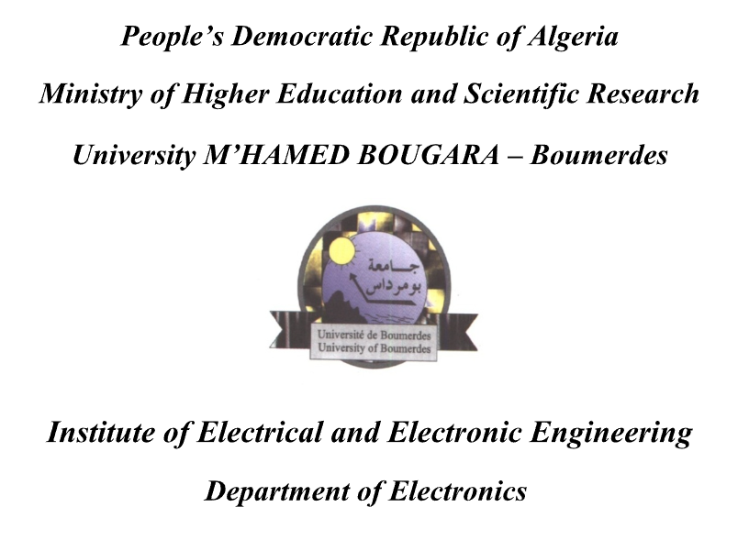



**WEB DEVLOPEMENT FINAL PROJECT:**

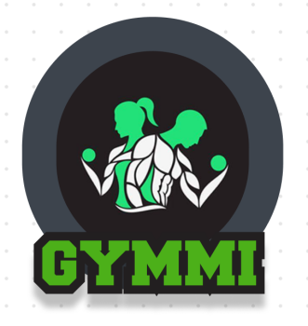 by Ahmed Yacine LADJICI

& Sara KARA

**Introduction**:

Capture d'écran 2024-03-29 175156is a website that offers all the necessities that you could need to start your journey in fitness wether its clothes , supliments and even gym subscribtions in diverse locations stragically spread out , increasing the likelihood of having a gym near the web user, and even if you are in need of a pack if you are a coach , beginner or intermidate that gathers up the best products u need with the best prices.

**The Design:**

By using Figma and utlising its properties we get to first design the website.

We start off by designing the logo of the brand and it results in:

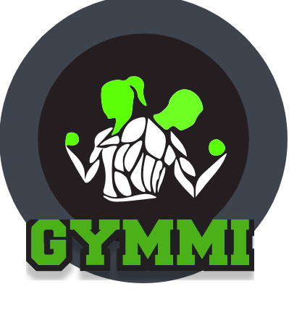

It represents two sports people and the brand’s name , the green color has been choosen since it represents strength and power and thats what the users look for .

The website is (for now) in dark mode.

**Navigation bar:**

The main page starts with a navigation bar that contains the logo , a search bar for the user to search the desired item if available , a shopping cart to confirm the ordered items , a profile icon to either sign in if new or log in into your account.



**Content:**

Fist section is an about section presenting what Capture d'écran 2024-03-29 175156is .

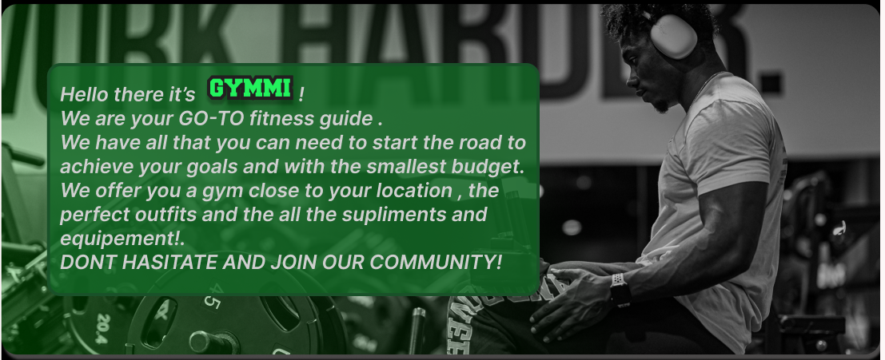

**A discount section :**

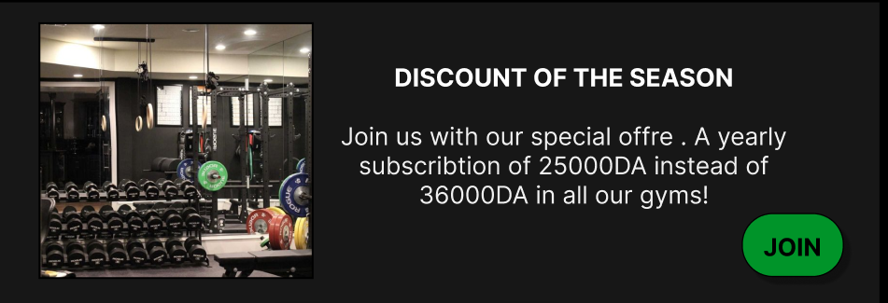

**A special packs section:**

Is a sliding carousel to present the three speacial packs available and the more button to see more packs in the product page that could be accessed by clicking on the more button.

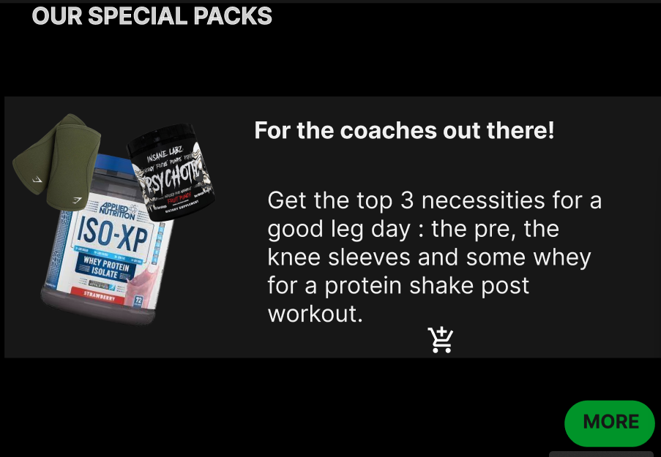

**Our Gyms:**

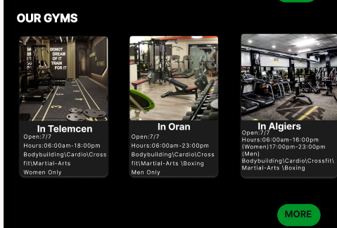

**Clothes:**

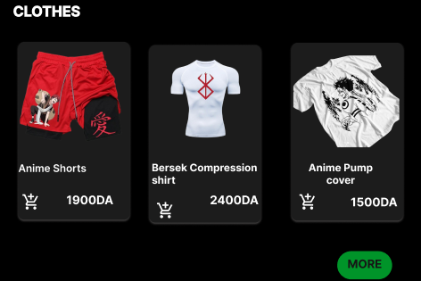

**Supliments:**

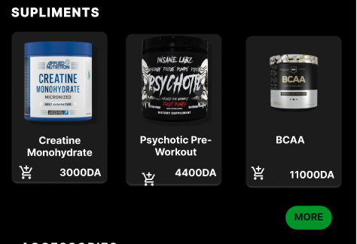

**Accessoires:**

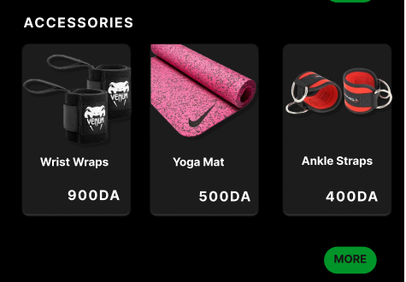

**The Footer:**

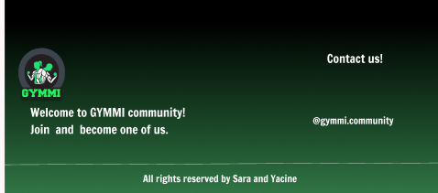

**conclusion**:

As a conclusion, this is not the full website, we have more modifications that we did not apply. We also face some problems when we did some decorations